Chapter 4, Problem 92.

Consider the bridge circuit of Fig. 4.148. Is the bridge balanced? If the 10 Ω resistor is replaced by an 18-kΩ resistor, what resistor connected between terminals a-b absorbs the maximum power? What is this power?.

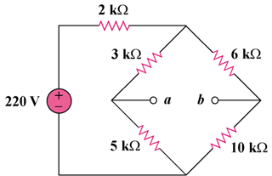

Figure 4.148
For Prob. 4.92.

